HSTS — High School Test System
3-Tier Architecture — Classes, Attributes, Methods & Relationships
Updated version — includes OCSF integration, StatisticsReport student filter, and restored content for ExamBuildingWindow / GradeApprovalWindow / BotManagementWindow
Summary of fixes applied in this version
- ExamBuildingWindow, GradeApprovalWindow, and BotManagementWindow: full attributes/methods restored (previously empty placeholder boxes in the diagram).
- BotManagementWindow: added usageStatsView, viewUsageButton, handleViewBotUsage() — supports R56, which had no screen calling Teacher.viewBotUsage().
- StatisticsReport: added filterStudent attribute and filterByStudent() method — needed by ReportsServerController.compareExamsByStudent() (R46).
- OCSF classes added: AbstractClient, AbstractServer, ConnectionToClient (given framework) plus HSTSClient / HSTSServer (your concrete subclasses), with relationships to every existing Control-tier class — new Part 3b and table 5.5.

Part 1 — Boundary Classes (Client UI)
LoginWindow
«Boundary»
Attributes
- usernameField: TextField
- passwordField: PasswordField
- loginButton: Button
- errorLabel: Label
- controller: LoginClientController
Methods
- handleLogin(): void
- showError(message): void

QuestionManagementWindow
«Boundary»
Attributes
- questionTextField: TextArea
- instructionsField: TextArea
- answer1-4Field: TextField x4
- correctAnswerSelector: RadioButton
- difficultySelector: ComboBox
- topicField: TextField
- imagePathField: TextField
- saveButton: Button
- deleteButton: Button
- searchButton: Button
- questionListView: ListView
- controller: QuestionClientController
Methods
- handleSaveQuestion(): void
- handleDeleteQuestion(): void
- handleSearchQuestions(): void
- displayQuestions(questions): void
- showError(message): void

ExamBuildingWindow
«Boundary»
Attributes
- examNameField: TextField
- durationField: TextField
- pointsPerQuestionField: TextField
- studentInstructionsField: TextArea
- teacherInstructionsField: TextArea
- questionListView: ListView
- selectedQuestionsListView: ListView
- courseSelector: ComboBox
- autoModeCheckBox: CheckBox
- numQuestionsField: TextField
- topicSelector: ComboBox
- difficultySelector: ComboBox
- saveButton: Button
- controller: ExamBuildingClientController
Methods
- handleSaveExam(): void
- handleAddQuestion(): void
- handleRemoveQuestion(): void
- handleAutoGenerate(): void
- displayQuestions(questions): void
- showError(message): void
Note: FIXED: this class was present only as an empty title box in the previous diagram version; content restored here.
ExamApprovalWindow
«Boundary»
Attributes
- examDetailsView: TextArea
- questionsListView: ListView
- approveButton: Button
- rejectButton: Button
- rejectionReasonField: TextArea
- pendingExamsListView: ListView
- controller: ExamApprovalClientController
Methods
- handleApproveExam(): void
- handleRejectExam(): void
- displayExamDetails(exam): void
- showError(message): void

ExecutionManagementWindow
«Boundary»
Attributes
- examSelector: ComboBox
- openingDateTimePicker: DateTimePicker
- closingDateTimePicker: DateTimePicker
- executionCodeField: TextField
- allocatedTimeField: TextField
- extendTimeField: TextField
- saveButton: Button
- extendTimeButton: Button
- controller: ExecutionClientController
Methods
- handleDefineExecution(): void
- handleExtendTime(): void
- showError(message): void

GradeApprovalWindow
«Boundary»
Attributes
- submissionsListView: ListView
- examSolutionView: TextArea
- automaticGradeLabel: Label
- finalGradeField: TextField
- teacherCommentsField: TextArea
- gradeChangeReasonField: TextArea
- approveButton: Button
- changeGradeButton: Button
- controller: GradeApprovalClientController
Methods
- handleApproveGrade(): void
- handleChangeGrade(): void
- displaySubmission(examSolution): void
- showError(message): void
Note: FIXED: this class was present only as an empty title box in the previous diagram version; content restored here.
StatisticsWindow
«Boundary»
Attributes
- examSelector: ComboBox
- averageLabel: Label
- medianLabel: Label
- decileChart: BarChart
- generateButton: Button
- controller: StatisticsClientController
Methods
- handleGenerateReport(): void
- displayReport(report): void

ReportsWindow
«Boundary»
Attributes
- dateFilterPicker: DatePicker
- courseFilterSelector: ComboBox
- teacherFilterSelector: ComboBox
- averageLabel: Label
- medianLabel: Label
- decileChart: BarChart
- comparisonChart: BarChart
- generateButton: Button
- controller: ReportsClientController
Methods
- handleGenerateReport(): void
- displayReport(report): void

BotManagementWindow
«Boundary»
Attributes
- botNameField: TextField
- courseSelector: ComboBox
- materialTypeSelector: ComboBox
- materialContentField: TextArea
- materialFilePathField: TextField
- usageStatsView: TextArea ← NEW
- activateButton: Button
- deactivateButton: Button
- addMaterialButton: Button
- viewUsageButton: Button ← NEW
- saveButton: Button
- controller: BotClientController
Methods
- handleCreateBot(): void
- handleAddMaterial(): void
- handleActivateBot(): void
- handleDeactivateBot(): void
- handleViewBotUsage(): void ← NEW
- showError(message): void
Note: FIXED: class was empty in the previous diagram version, AND the view-usage UI (usageStatsView, viewUsageButton, handleViewBotUsage) is newly added to support R56, which had no screen calling Teacher.viewBotUsage().
ExamExecutionWindow
«Boundary»
Attributes
- executionCodeField: TextField
- studentIdField: TextField
- questionTextLabel: Label
- answer1-4Button: RadioButton x4
- timerLabel: Label
- nextButton: Button
- previousButton: Button
- submitButton: Button
- controller: ExamExecutionClientController
Methods
- handleEnterCode(): void
- handleStartExam(): void
- handleSelectAnswer(): void
- handleSubmitExam(): void
- handleNextQuestion(): void
- handlePreviousQuestion(): void
- updateTimer(remainingSeconds): void
- showError(message): void

ResultsWindow
«Boundary»
Attributes
- examsListView: ListView
- gradeLabel: Label
- questionsResultView: ListView
- teacherCommentsLabel: Label
- downloadButton: Button
- controller: ResultsClientController
Methods
- handleViewResult(): void
- handleDownloadExam(): void
- displayGradedExam(gradedExam): void

BotWindow
«Boundary»
Attributes
- questionField: TextArea
- answerField: TextArea
- sendButton: Button
- historyListView: ListView
- viewHistoryButton: Button
- controller: BotClientController
Methods
- handleSendQuestion(): void
- handleViewHistory(): void
- displayAnswer(answer): void
- displayHistory(history): void

Part 2 — Control Classes (Client Side)
LoginClientController
«Control»
Attributes
- currentUser: User
Methods
- login(username, password): User
- logout(): void
- handleLoginResponse(response): void

QuestionClientController
«Control»
Attributes
- currentQuestion: Question
Methods
- createQuestion(text, instructions, difficulty, topic, imagePath, course): void
- editQuestion(question): void
- deleteQuestion(question): void
- searchQuestions(topic, difficulty, course): void
- handleResponse(response): void

ExamBuildingClientController
«Control»
Attributes
- currentExam: Exam
Methods
- createExam(course, duration, pointsPerQ, studentInstr, teacherInstr): void
- addQuestion(exam, question): void
- removeQuestion(exam, question): void
- saveExam(exam): void
- createAutomaticExam(course, numQ, topics, difficulty): void
- loadExams(): void
- createNewVersion(exam): void
- handleResponse(response): void

ExamApprovalClientController
«Control»
Attributes
- currentExam: Exam
Methods
- loadPendingExams(): void
- approveExam(exam): void
- rejectExam(exam, reason): void
- handleResponse(response): void

ExecutionClientController
«Control»
Attributes
- currentExecution: ExecutionInstance
Methods
- defineExecution(exam, openingDT, closingDT, code): void
- extendTime(execution, extraMinutes): void
- handleResponse(response): void

ExamExecutionClientController
«Control»
Attributes
- currentExamSolution: ExamSolution
- remainingSeconds: int
- timer: Timer
Methods
- enterExecutionCode(code): void
- startExam(studentId): void
- selectAnswer(question, answer): void
- navigateToQuestion(index): void
- submitExam(): void
- updateTimer(): void
- handleAutoSubmit(): void
- handleResponse(response): void

GradeApprovalClientController
«Control»
Attributes
- currentGradedExam: GradedExam
Methods
- loadPendingSubmissions(): void
- approveGrade(gradedExam): void
- changeGrade(gradedExam, newGrade, explanation): void
- addComment(gradedExam, comment): void
- handleResponse(response): void

StatisticsClientController
«Control»
Attributes
- currentReport: StatisticsReport
Methods
- generateReport(exam): void
- handleResponse(response): void

ReportsClientController
«Control»
Attributes
- currentReport: StatisticsReport
Methods
- generateReport(filterDate, filterCourse, filterTeacher): void
- handleResponse(response): void

BotClientController
«Control»
Attributes
- currentBot: Bot
Methods
- createBot(name, course, materials): void
- addMaterial(bot, material): void
- activateBot(bot): void
- deactivateBot(bot): void
- sendQuestion(bot, question): void
- viewHistory(): void
- viewBotUsage(bot): void
- handleResponse(response): void

ResultsClientController
«Control»
Attributes
- currentGradedExam: GradedExam
Methods
- loadResults(): void
- viewGradedExam(gradedExam): void
- downloadGradedExam(gradedExam): void
- handleResponse(response): void

HSTSClient
«Control» (extends AbstractClient)
Attributes
(none)
Methods
- handleMessageFromServer(msg: Object): void — override; dispatches the response to the matching *ClientController based on message type
Note: NEW — concrete OCSF client. Every *ClientController above sends its requests through this single connection object.

Part 3 — Control Classes (Server Side)
LoginServerController
«Control»
Attributes
- activeSessions: Map
Methods
- login(username, password): User
- logout(user): void
- isAlreadyLoggedIn(user): boolean

QuestionServerController
«Control»
Attributes
(none)
Methods
- createQuestion(teacher, course, text, instructions, difficulty, topic, imagePath): Question
- editQuestion(teacher, question, ...): void
- deleteQuestion(teacher, question): void
- searchQuestions(course, topic, difficulty): List
- generateQuestionId(course): String

ExamBuildingServerController
«Control»
Attributes
(none)
Methods
- createExam(teacher, course, duration, pointsPerQ, studentInstr, teacherInstr): Exam
- addQuestion(exam, question): void
- removeQuestion(exam, question): void
- saveExam(exam): void
- createAutomaticExam(teacher, course, numQ, topics, difficulty): Exam
- calculateTotalPoints(exam): int
- generateExamId(course, subject): String
- createNewVersion(exam): Exam
- loadExams(teacher): List

ExamApprovalServerController
«Control»
Attributes
(none)
Methods
- loadPendingExams(coordinator): List
- approveExam(coordinator, exam): void
- rejectExam(coordinator, exam, reason): void
- viewExamDetails(exam): Exam

ExecutionServerController
«Control»
Attributes
(none)
Methods
- defineExecution(teacher, exam, openDT, closeDT, code): ExecutionInstance
- extendTime(execution, extraMinutes): void
- isExamAvailable(execution): boolean
- documentExecution(execution): void

ExamExecutionServerController
«Control»
Attributes
(none)
Methods
- validateExecutionCode(code): ExecutionInstance
- startExam(execution, studentId): ExamSolution
- saveAnswer(examSolution, question, answer): void
- submitExam(examSolution): void
- autoSubmit(examSolution): void
- recordStart(execution): void
- recordFinish(execution): void
- recordDidntFinish(execution): void

AutoGradingServerController
«Control»
Attributes
(none)
Methods
- gradeExam(examSolution): GradedExam
- calculateGrade(examSolution, examAnswer): int
- gradeQuestion(questionSolution, examAnswer): GradedQuestion
- calculateStatistics(execution): StatisticsReport
Note: Server-only; no Boundary/Client counterpart. Triggered internally by ExamExecutionServerController after submission.
GradeApprovalServerController
«Control»
Attributes
(none)
Methods
- loadPendingSubmissions(teacher): List
- approveGrade(teacher, gradedExam): void
- changeGrade(teacher, gradedExam, newGrade, explanation): void
- addComment(teacher, gradedExam, comment): void

StatisticsServerController
«Control»
Attributes
(none)
Methods
- generateReport(teacher, exam): StatisticsReport
- calculateAverage(gradedExams): double
- calculateMedian(gradedExams): double
- calculateDecileDistribution(gradedExams): List

ReportsServerController
«Control»
Attributes
(none)
Methods
- generateReport(filterDate, filterCourse, filterTeacher): StatisticsReport
- compareExamsByTeacher(teacher): StatisticsReport
- compareExamsByCourse(course): StatisticsReport
- compareExamsByStudent(student): StatisticsReport
- getAllData(): List

BotServerController
«Control»
Attributes
(none)
Methods
- createBot(teacher, course, name): Bot
- addMaterial(teacher, bot, material): void
- activateBot(bot): void
- deactivateBot(bot): void
- sendQuestion(student, bot, question): BotInteraction
- isAvailable(student, bot): boolean
- viewBotUsage(bot): void
- getBotHistory(student): List
- saveInteraction(student, bot, question, answer): BotInteraction

ResultsServerController
«Control»
Attributes
(none)
Methods
- loadResults(student): List
- viewGradedExam(student, gradedExam): GradedExam
- downloadGradedExam(student, gradedExam): File

HSTSServer
«Control» (extends AbstractServer)
Attributes
(none)
Methods
- handleMessageFromClient(msg: Object, client: ConnectionToClient): void — override; routes the request to the matching *ServerController based on message type
Note: NEW — concrete OCSF server. Listens for connections and dispatches every incoming request to the right *ServerController.

Part 3b — OCSF Framework Classes (Given)
AbstractClient
«OCSF — given»
Attributes
(none)
Methods
- openConnection(): void
- sendToServer(msg: Object): void
- closeConnection(): void
- handleMessageFromServer(msg: Object): void (abstract — implemented by HSTSClient)
Note: Provided by the course framework, not implemented by the team.
AbstractServer
«OCSF — given»
Attributes
(none)
Methods
- listen(): void
- close(): void
- sendToAllClients(msg: Object): void
- handleMessageFromClient(msg: Object, client: ConnectionToClient): void (abstract — implemented by HSTSServer)
Note: Provided by the course framework, not implemented by the team.
ConnectionToClient
«OCSF — given»
Attributes
(none)
Methods
- sendToClient(msg: Object): void
Note: Provided by the course framework. One instance per connected client, managed by AbstractServer/HSTSServer.
These three classes are provided by the course’s OCSF framework and are not implemented by the team. HSTSClient and HSTSServer (Part 2 / Part 3) are the team’s concrete subclasses that plug into this framework.

Part 4 — Entity Classes (Server, Persisted)
User
«abstract, Entity»
Attributes
- id: String
- firstName: String
- lastName: String
- email: String
- password: String
- role: String
Methods
- login(): boolean
- logout(): void

Teacher
«Entity» (extends User)
Attributes
- courses: List
Methods
- createQuestion(course, text, instructions, difficulty, topic): Question
- editQuestion(question): void
- deleteQuestion(question): void
- searchQuestions(topic, difficulty, course): List
- createExam(course): Exam
- createAutomaticExam(course, numQuestions, topics, difficulty): Exam
- defineExecutionInstance(exam, openingDateTime, closingDateTime): ExecutionInstance
- extendExamTime(executionInstance, extraTime): void
- approveGrade(gradedExam): void
- changeGrade(gradedExam, newGrade, explanation): void
- addCommentToGrade(gradedExam, comment): void
- getStatisticsReport(course): StatisticsReport
- createBot(course, name, materials): Bot
- addBotMaterial(bot, material): void
- viewBotUsage(bot): void

SubjectCoordinator
«Entity» (extends Teacher)
Attributes
(none)
Methods
- approveExam(exam): void
- rejectExam(exam, reason): void
- viewExamDetails(exam): void

Student
«Entity» (extends User)
Attributes
- courses: List
Methods
- enterExecutionCode(code): ExecutionInstance
- startExam(executionInstance, studentId): ExamSolution
- answerQuestion(examSolution, question, answer): void
- submitExam(examSolution): void
- viewGrades(): List
- viewGradedExam(gradedExam): void
- askBot(bot, question): BotInteraction
- viewBotHistory(): List

Principal
«Entity» (extends User)
Attributes
(none)
Methods
- viewAllData(): void
- requestStatisticsReport(filterDate, filterCourse, filterTeacher): StatisticsReport

Course
«Entity»
Attributes
- courseId: String
- name: String
Methods
- getQuestionBank(): QuestionBank
- getExamBank(): ExamBank
- getBot(): Bot

Subject
«Entity»
Attributes
- subjectId: String
- name: String
Methods
(none)

QuestionBank
«Entity»
Attributes
- questions: List
Methods
- addQuestion(question): void
- removeQuestion(question): void
- searchQuestions(topic, difficulty): List
- getQuestionById(id): Question

Question
«Entity»
Attributes
- questionId: String
- text: String
- instructions: String
- difficulty: enum {EASY, MEDIUM, HARD}
- topic: String
- imagePath: String // optional
Methods
- getCorrectAnswer(): QuestionAnswer

QuestionAnswer
«Entity»
Attributes
- text: String
- isCorrect: boolean
Methods
- isCorrect(): boolean

ExamBank
«Entity»
Attributes
- exams: List
Methods
- addExam(exam): void
- removeExam(exam): void
- getExamById(id): Exam
- getExamsByStatus(status): List

Exam
«Entity»
Attributes
- examId: String
- duration: int
- pointsPerQuestion: int
- studentInstructions: String
- teacherInstructions: String
- status: enum {PENDING, APPROVED, REJECTED}
- rejectionReason: String // null if not rejected
Methods
- addQuestion(question): void
- removeQuestion(question): void
- calculateTotalPoints(): int
- approve(): void
- reject(reason): void
- createNewVersion(): Exam

ExamAnswer
«Entity»
Attributes
- correctAnswers: List
Methods
- getCorrectAnswer(question): QuestionAnswer
- generateFromExam(exam): void

ExecutionInstance
«Entity»
Attributes
- executionCode: String
- openingDateTime: DateTime
- closingDateTime: DateTime
- allocatedTime: int
- numStarted: int
- numFinished: int
- numDidntFinish: int
Methods
- isActive(): boolean
- extendTime(extraMinutes): void
- recordStart(): void
- recordFinish(): void
- recordDidntFinish(): void
- generateStatistics(): StatisticsReport

ExamSolution
«Entity»
Attributes
- startTime: DateTime
- submitTime: DateTime
- actualDuration: int
- status: enum {IN_PROGRESS, SUBMITTED, AUTO_SUBMITTED}
- questionSolutions: List
Methods
- addQuestionSolution(questionSolution): void
- submit(): void
- autoSubmit(): void
- calculateActualDuration(): void

QuestionSolution
«Entity»
Attributes
- selectedAnswer: QuestionAnswer
Methods
- selectAnswer(answer): void
- changeAnswer(answer): void

GradedExam
«Entity»
Attributes
- automaticGrade: int
- finalGrade: int
- teacherComments: String
- isApproved: boolean
- gradedQuestions: List
- gradeChangeLog: List
Methods
- calculateAutomaticGrade(): int
- approveGrade(): void
- changeGrade(newGrade, explanation): void
- addComment(comment): void
- isAvailableToStudent(): boolean

GradedQuestion
«Entity»
Attributes
- isCorrect: boolean
- pointsAwarded: int
Methods
- grade(questionSolution, examAnswer): void

GradeChange
«Entity»
Attributes
- timestamp: DateTime
- explanation: String
- previousGrade: int
- newGrade: int
Methods
(none)

Bot
«Entity»
Attributes
- name: String
- isActive: boolean
- course: Course
Methods
- activate(): void
- deactivate(): void
- addMaterial(material): void
- sendQuestion(question): BotInteraction
- isAvailable(student, executionInstance): boolean

BotMaterial
«Entity»
Attributes
- type: enum {WORD, PDF, TEXT, QUESTION_BANK}
- content: String // null if type = QUESTION_BANK
- questionBank: QuestionBank // null if type ≠ QUESTION_BANK
Methods
- getContent(): String

BotInteraction
«Entity»
Attributes
- question: String
- answer: String
- timestamp: DateTime
- student: Student
Methods
(none)

StatisticsReport
«Entity»
Attributes
- average: double
- median: double
- decileDistribution: List
- filterDate: DateTime
- filterCourse: Course
- filterTeacher: Teacher
- filterStudent: Student ← NEW
- exams: List
Methods
- generate(): void
- filterByDate(date): void
- filterByCourse(course): void
- filterByTeacher(teacher): void
- filterByStudent(student): void ← NEW
- compareExams(): void
Note: FIXED: filterStudent / filterByStudent were missing even though ReportsServerController.compareExamsByStudent() already depends on this filter to satisfy requirement R46 (compare grades across a single student's exams).

Part 5 — 3-Tier Relationships

5.1 Boundary → Control (Client)
From | Relation | To | Multiplicity | Type
LoginWindow | uses | LoginClientController | 1-to-1 | Association
QuestionManagementWindow | uses | QuestionClientController | 1-to-1 | Association
ExamBuildingWindow | uses | ExamBuildingClientController | 1-to-1 | Association
ExamApprovalWindow | uses | ExamApprovalClientController | 1-to-1 | Association
ExecutionManagementWindow | uses | ExecutionClientController | 1-to-1 | Association
GradeApprovalWindow | uses | GradeApprovalClientController | 1-to-1 | Association
StatisticsWindow | uses | StatisticsClientController | 1-to-1 | Association
ReportsWindow | uses | ReportsClientController | 1-to-1 | Association
BotManagementWindow | uses | BotClientController | 1-to-1 | Association
ExamExecutionWindow | uses | ExamExecutionClientController | 1-to-1 | Association
ResultsWindow | uses | ResultsClientController | 1-to-1 | Association
BotWindow | uses | BotClientController | 1-to-1 | Association

5.2 Control (Client) → Control (Server)
From | Relation | To | Multiplicity | Type
LoginClientController | sends requests to | LoginServerController | 1-to-1 | Association
QuestionClientController | sends requests to | QuestionServerController | 1-to-1 | Association
ExamBuildingClientController | sends requests to | ExamBuildingServerController | 1-to-1 | Association
ExamApprovalClientController | sends requests to | ExamApprovalServerController | 1-to-1 | Association
ExecutionClientController | sends requests to | ExecutionServerController | 1-to-1 | Association
ExamExecutionClientController | sends requests to | ExamExecutionServerController | 1-to-1 | Association
GradeApprovalClientController | sends requests to | GradeApprovalServerController | 1-to-1 | Association
StatisticsClientController | sends requests to | StatisticsServerController | 1-to-1 | Association
ReportsClientController | sends requests to | ReportsServerController | 1-to-1 | Association
BotClientController | sends requests to | BotServerController | 1-to-1 | Association
ResultsClientController | sends requests to | ResultsServerController | 1-to-1 | Association

5.3 Special Server-Side Trigger
From | Relation | To | Multiplicity | Type
ExamExecutionServerController | triggers | AutoGradingServerController | 1-to-1 | Triggers

5.4 Control (Server) → Entity
From | Relation | To | Multiplicity | Type
LoginServerController | accesses | User | 1-to-many | Accesses
QuestionServerController | accesses | Question, QuestionAnswer, QuestionBank, Course | 1-to-many | Accesses
ExamBuildingServerController | accesses | Exam, ExamBank, ExamAnswer, Question, Course, Subject | 1-to-many | Accesses
ExamApprovalServerController | accesses | Exam, Teacher, SubjectCoordinator | 1-to-many | Accesses
ExecutionServerController | accesses | ExecutionInstance, Exam | 1-to-many | Accesses
ExamExecutionServerController | accesses | ExamSolution, QuestionSolution, ExecutionInstance, Student | 1-to-many | Accesses
AutoGradingServerController | accesses | GradedExam, GradedQuestion, ExamAnswer, ExamSolution, StatisticsReport | 1-to-many | Accesses
GradeApprovalServerController | accesses | GradedExam, GradeChange, Teacher | 1-to-many | Accesses
StatisticsServerController | accesses | StatisticsReport, GradedExam, Exam, Teacher | 1-to-many | Accesses
ReportsServerController | accesses | StatisticsReport, GradedExam, Exam, Course, Teacher, Student | 1-to-many | Accesses
BotServerController | accesses | Bot, BotMaterial, BotInteraction, Student, Course, QuestionBank | 1-to-many | Accesses
ResultsServerController | accesses | GradedExam, GradedQuestion, Student | 1-to-many | Accesses

5.5 OCSF Integration (New)
Shows how the existing Control-tier classes connect to the OCSF framework via HSTSClient / HSTSServer.
From | Relation | To | Multiplicity | Type
HSTSClient | extends | AbstractClient | — | Inheritance
HSTSServer | extends | AbstractServer | — | Inheritance
HSTSServer | manages | ConnectionToClient | 1-to-many | Association
LoginClientController | uses | HSTSClient | many-to-1 | Association
QuestionClientController | uses | HSTSClient | many-to-1 | Association
ExamBuildingClientController | uses | HSTSClient | many-to-1 | Association
ExamApprovalClientController | uses | HSTSClient | many-to-1 | Association
ExecutionClientController | uses | HSTSClient | many-to-1 | Association
ExamExecutionClientController | uses | HSTSClient | many-to-1 | Association
GradeApprovalClientController | uses | HSTSClient | many-to-1 | Association
StatisticsClientController | uses | HSTSClient | many-to-1 | Association
ReportsClientController | uses | HSTSClient | many-to-1 | Association
BotClientController | uses | HSTSClient | many-to-1 | Association
ResultsClientController | uses | HSTSClient | many-to-1 | Association
HSTSServer | routes to | LoginServerController | 1-to-many | Association
HSTSServer | routes to | QuestionServerController | 1-to-many | Association
HSTSServer | routes to | ExamBuildingServerController | 1-to-many | Association
HSTSServer | routes to | ExamApprovalServerController | 1-to-many | Association
HSTSServer | routes to | ExecutionServerController | 1-to-many | Association
HSTSServer | routes to | ExamExecutionServerController | 1-to-many | Association
HSTSServer | routes to | GradeApprovalServerController | 1-to-many | Association
HSTSServer | routes to | StatisticsServerController | 1-to-many | Association
HSTSServer | routes to | ReportsServerController | 1-to-many | Association
HSTSServer | routes to | BotServerController | 1-to-many | Association
HSTSServer | routes to | ResultsServerController | 1-to-many | Association

2. Class Diagram
Visual export of the 3-tier class diagram. The editable Draw.io file with corrected arrows is provided separately.


3. Activity Diagrams
Activity Diagram - Building an Exam


Activity Diagram - Taking an Exam
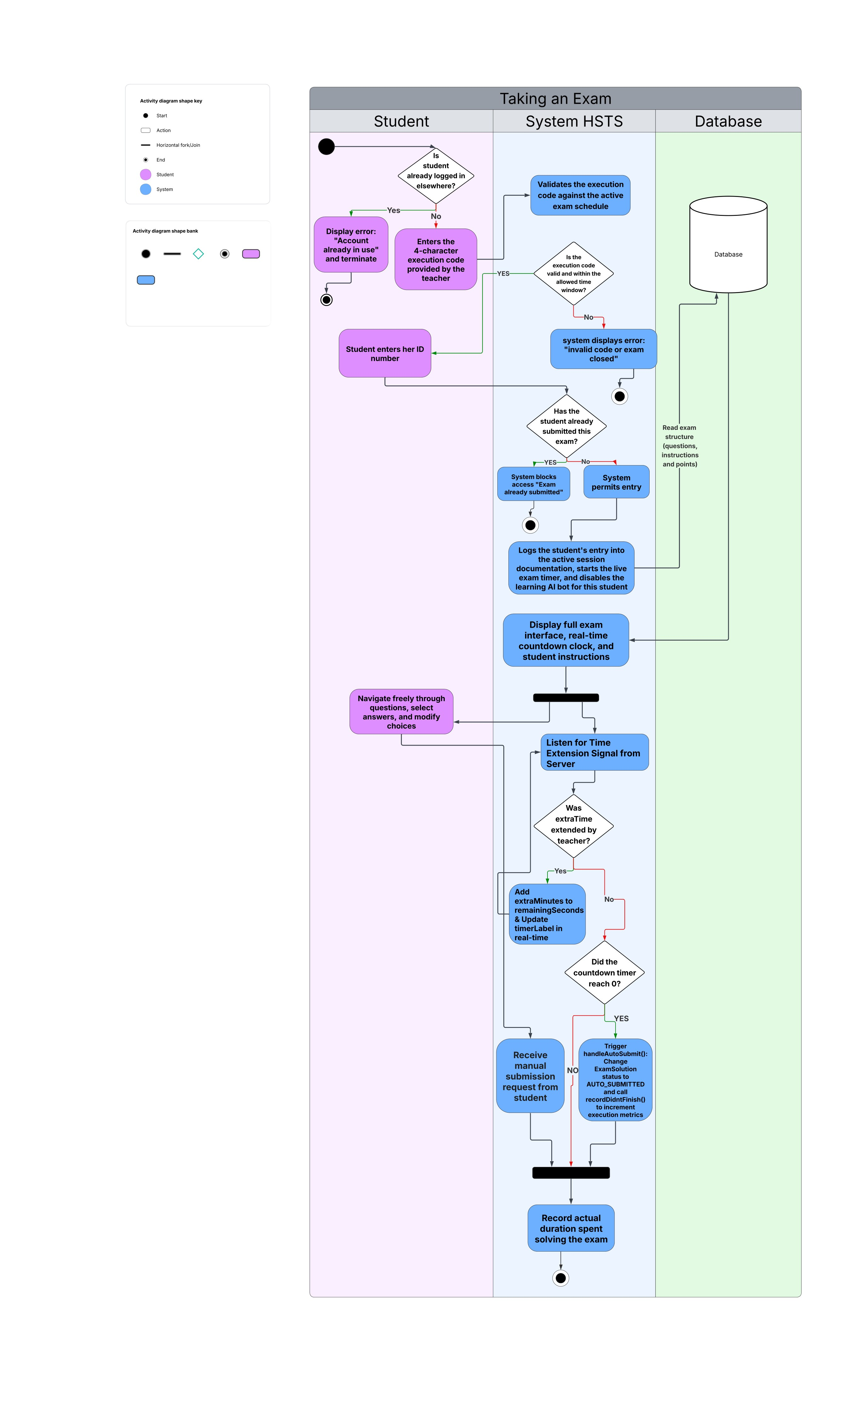

Activity Diagram - Viewing Exam Results
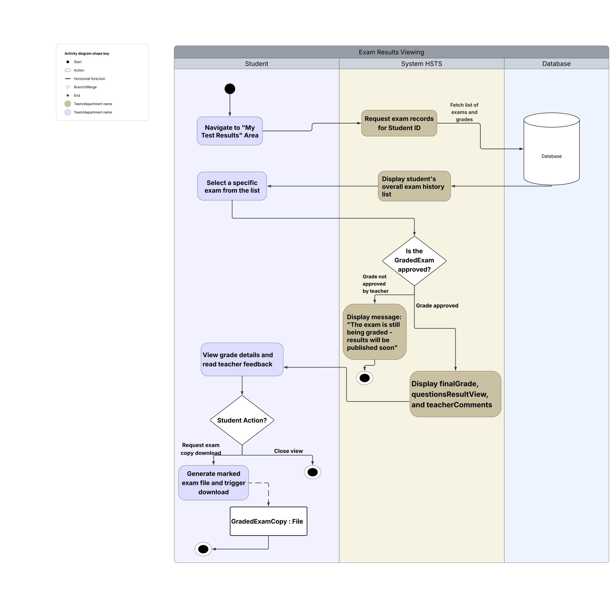

4. Sequence Diagrams
Sequence Diagram - Building an Exam
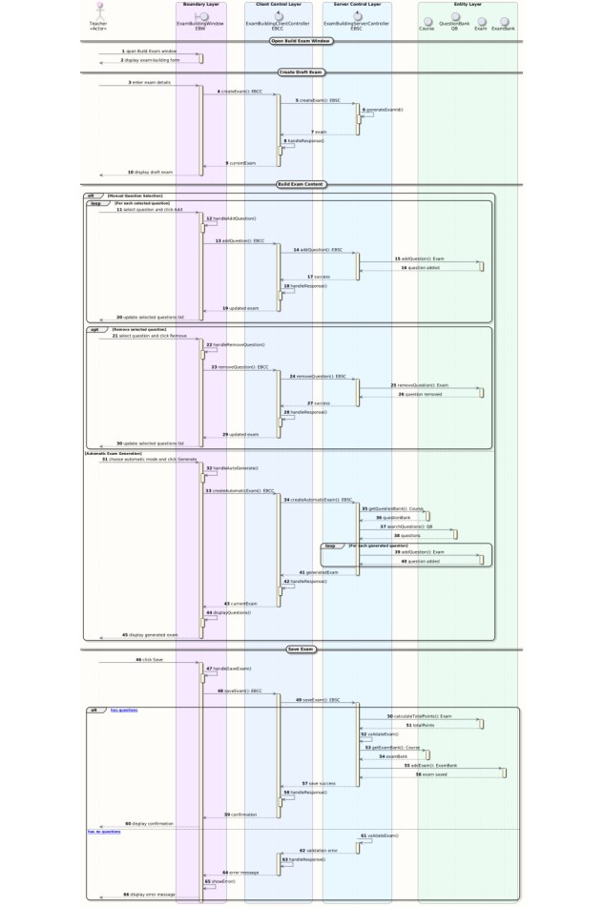

Sequence Diagram - Taking an Exam
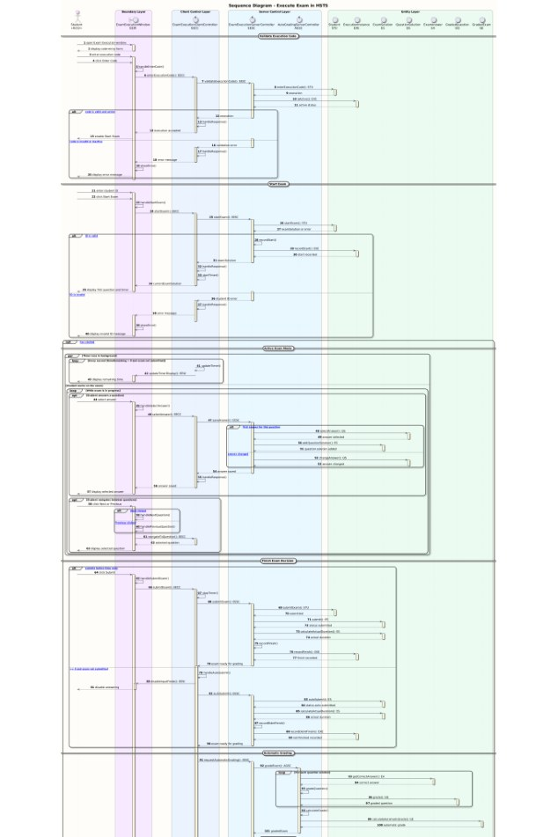

Sequence Diagram - Viewing Exam Results
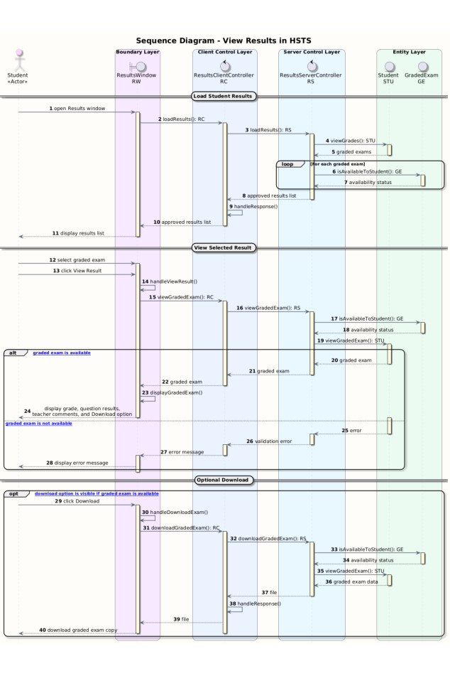

5. Backward Traceability Table
Class responsibility and backward traceability table, including OCSF classes.
